**INPUT**

**Write a shell program to count the number of files using the command line argument.**

n=$#

echo "Number of input file = $n"

**OUTPUT**

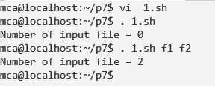

**INPUT**

**Write a shell program to accept a date and validate if it is in the specified format(e.g. 31st Jan,2014)**

echo "Enter date in the format of 02-04-17 in specific range only"

echo "Enter date: "

read d

if echo $d|grep [0-3][0-9][-][0-1][0-9][-][0-9][0-9]

then

echo "$d is a valid date!"

else

echo "$d is not a valid date!"

fi

**OUTPUT**

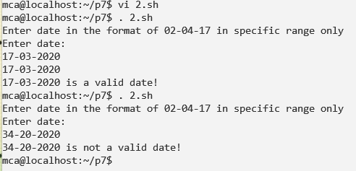

**INPUT**

**Write a shell script to accept a file name from the user and check whether the file has write Accessibility or not.**

echo "Enter filename: "

read f

if [ -w $f ]

then

echo "$f has write permissions"

else

echo "$f does not write permissions"

fi

**OUTPUT**

